##### A Project report

##### on

**UNIVERSITY MANAGEMENT SYSTEM**

###### A Dissertation submitted to JNTU Hyderabad in partial fulfillment of the academic requirements for the award of the degree.

**Bachelor of Technology**

**In**

**Computer Science and Engineering**

Submitted by

##### CH. Harshitha 19H51A05A0

##### G. Vamshi Reddy 19H51A05A1

##### Y. Archana 19H51A05C1

Under the esteemed guidance of

Mr. G. Ravi Kumar

Assistant Professor CSE Department



**Department of Computer Science and Engineering**

**CMR COLLEGE OF ENGINEERING AND TECHNOLOGY**

(An Autonomous Institution under UGC & JNTUH, Approved by AICTE, Permanently Affiliated to JNTUH, Accredited by NBA.)

KANDLAKOYA, MEDCHAL ROAD, HYDERABAD - 501401.

2019- 2023

**CMR COLLEGE OF ENGINEERING & TECHNOLOGY**

KANDLAKOYA, MEDCHAL ROAD, HYDERABAD – 501401

**DEPARTMENT OF COMPUTER SCIENCE AND ENGINEERING**



#### CERTIFICATE

This is to certify that the Mini Project-1 report entitled **" UNIVERSITY MANAGEMENT SYSTEM"** being submitted by **CH.HARSHITHA (19H51A05A0), G.VAMSHI REDDY (19H51A05A1), Y. ARCHANA (19H51A05C1)** in partial fulfillment for the award of **Bachelor of Technology in Computer Science and Engineering** is a record of bonafide work carried out his/her under my guidance and supervision.

###### The results embodies in this project report have not been submitted to any other University or Institute for the award of any Degree.

**Mr. G. Ravi Kumar Dr. K Vijaya Kumar**

**Assistant Professor Professor and HOD**

**Dept of CSE Dept of CSE**

Submitted for viva voice Examination held on

**External Examiner**

**Acknowledgment**

We are highly indebted and grateful to our guide to our guide  **Mr. G. RAVI KUMAR** Asst. Professor, Department of CSE, CMRCET for his excellent guidance and constant encouragement throughout for the Successful completion of the project.

We are obliged and grateful to thank **Dr. K VIJAYA KUMAR**, Head of the Department of Computer Science

And Engineering, CMRCET, for his cooperation in all respects.

We would like to thank Major **Dr. V. A .NARAYANA,** Principal, CMRCET, for his support in the course of this project work.

We would like thank Sri **Ch. GOPAL REDDY** garu, Secretary & correspondent of CMRCET, for his cooperation in all respects during the course.

Finally, we would like to thank all teaching & non-teaching staff members of the department, for their cooperation and support throughout the duration of our course.

Ultimately, we owe all our success to our beloved parents, whose vision, love and inspiration has made us reach out for these glories.

**SIGNATURE**

CH HARSHITHA 19H51A05A0

G VAMSHI REDDY 19H51A05A1

Y ARCHANA 19H51A05C1

**DECLARATION**

We hereby declare that results embodied in this Report of Projection **“UNIVERSITY MANAGEMENT SYSTEM”** are from the work carried out by using partial fulfillment of the requirements for the award of B. Tech degree. We have not submitted this report to any other university/institute for the award of any other degree.

**SIGNATURE**

CH HARSHITHA 19H51A05A0

G VAMSHI REDDY 19H51A05A1

Y ARCHANA 19H51A05C1

**TABLE OF CONTENTS**

**CHAPTER NO TITLE PAGE NO**

**ABSTRACT**

**1 INTRODUCTION 1**

1.1 Overview

1.2 Purpose

1.3 Scope

**2** **BACKGROUND WORK 2-7**

2.1 Hardware Requirements

2.2 Software Requirements

2.3 Overview of a front end

2.3.1 About Java

2.4 Overview of a back end

2.4.1 About SQL

2.5 Requirement Analysis

2.5.1 E-R Diagram

2.5.2 Schema Diagram

**3 PROPOSED SYSTEM 8-15**

3.1 Table Description

3.1.1 Database Designs

3.2 Implementation

**4 DESIGNING 16**

4. 1 Testing

4.1.1 Unit Testing

4.1.2 Integration Testing

4.1.3 User Acceptance

4.1.4 Test Cases

**5 RESULTS AND DISCUSSION 17-20**

**6 CONCLUSON AND FUTURE WORK 21**

**7 REFERENCES** **22**

**LIST OF FIGURES**

|  |  |  |
| --- | --- | --- |
| **FIGURE NO.** | **TITLE** | **PAGE NO.** |
| 2.1 | E-R DIAGRAM | 6 |
| 2.2 | SCHEMA DIAGRAM | 7 |
| 5.1 | LOGIN FORM | 17 |
| 5.2 | SIGNUP PAGE | 17 |
| 5.3 | HOME PAGE USER | 18 |
| 5.4 | STUDENT FORM | 18 |
| 5.5 | TEACHER FORM | 19 |
| 5.6 | MARKS AND SUJECT PAGE | 19 |
| 5.7 | FEE PAYMENT PAGE | 20 |

**List of Tables**

|  |  |  |
| --- | --- | --- |
| **TABLE NO.** | **TITLE** | **PAGE NO.** |
| 3.1 | ACCOUNT TABLEDESCRIPTION | 8 |
| 3.2 | STUDENT TABLE DESCRIPTION | 8 |
| 3.3 | TEACHER TABLE DESCRIPTION | 9 |
| 3.4 | ATTENDENCE STUDENT TABLE DESCRIPTION | 9 |
| 3.5 | ATTENDENCE TEACHER TABLE DESCRIPTION | 10 |
| 3.6 | SUBJECT TABLE DESCRIPTION | 10 |
| 3.7 | MARKS TABLE DESCRIPTION | 11 |
| 3.8 | FEE TABLE | 11 |

#### ABSTRACT

Every University/College/Organization, regardless of being big or small have challenges to overcome in managing the information of Students, Faculty, Courses, Fee structure, Attendance etc... at the management level. In this fast-growing world everything depends on the data, so people are tending to give more importance for the security of the data. As the technology is growing rapidly, everything is expected to be automatic with less labor force. Hence, we produced an idea of developing a web application called “UNIVERSITY MANAGEMENT SYSTEM” which deals with the maintenance of university data, records, instructions, and students’ information within the University.

UMS is an automation system, which is used to store the information, student’s record, and information of Courses. Starting from registration of a new student in the college, it maintains all the details regarding the attendance and marks of the student. It collects related information from all the departments of an organization and maintains files, which are used to generate reports in various forms to measure Individual and overall performance of the students.

1. **INTRODUCTION**
   1. **Overview:**

UNIVERSITY MANAGEMENT SYSTEM (UMS) is a flagship product of Easy Solution which covers all aspects of Universities, Colleges or Schools. UMS covers every minute aspects of a universities work flow and integrates all processes with user friendly interface. With hundreds of satisfied customers UMS is first choice of several state, governments/semi- government universities and institutions. UMS is an outcome of hard work done by our expert technical team in supervision of several renowned educationists which includes Controller of examination, faculties. UMS is a rare combination of experience and precision. UMS streamline path of information flow in organization by taking care of following departments:

* Fee Department
* Examination Department
* Attendance
* Faculty information portal
* Student information portal

## Purpose:

* + Drive operational efficiency.
  + Self-service systems with simple to use with little or no training.
  + Elimination of duplicate data entry processes.
  + Integrated with Online Application workflow with unified data model.
  + Monitoring and decision support system.
  + Automation of all the Academic / Examination / Administration operations.
  + Ease and accuracy of reporting.
  1. **Scope:**

This project deals with the various functioning in college management process. The main idea is to implement a proper process to system. In our existing system contains many operations registrations, student search, fees, attendance, exam records, performance of the student etc. All these activity takeout manually by administrator.

**2. BACKGROUND WORK**

**REQUIREMENT SPECIFICATIONS**

## Hardware Requirements:

|  |  |
| --- | --- |
| Processor Brand | : Intel |
| Processor Type | : Core i3 |
| Processor Speed | : 2 GHz |
| Processor Count | : 1 |
| RAM Size | : 2 GB |
| Memory Technology | : DDR3 |
| Computer Memory Type | : DDR3 SDRAM |
| Hard Drive Size | : 160 GB |

* 1. **Software Requirements :**

Operating system : Windows 10

Application server : JAVA (Net Beans)

Front end : JAVA

Connectivity : JDBC Driver

Database connectivity : WAMP (MYSQL Console)

## 2.3 Overview of Front End

An important issue for the development of a project is the selection of suitable front- end and back-end. When we decided to develop the project we went through an extensive study to determine the most suitable platform that suits the needs of the organization as well as helps in development of the project. The aspects of our study included the following factors. Front-end selection:

* It must have a graphical user interface that assists employees that are not from IT background.
* Scalability and extensibility.
* Flexibility.
* Robustness.
* According to the organization requirement and the culture.
* Must provide excellent reporting features with good printing support.
* Platform independent.
* Easy to debug and maintain.
* Event driven programming facility.
* Front end must support some popular back end like My SQL.
* According to the above stated features we selected PHP and CSS as the front-end for developing.

### 2.3.1 About Java:

Java is a general-purpose, class-based, object-oriented programming language designed for having lesser implementation dependencies. It is a computing platform for application development. Java is fast, secure, and reliable, therefore. It is widely used for developing Java applications in laptops, data centres, game consoles, scientific supercomputers, cell phones ,etc.

Here are some important Java applications:

* It is used for developing Android Apps
* Helps you to create Enterprise Software
* Wide range of Mobile java Applications
* Scientific Computing Applications
* Use for Big Data Analytics
* Java Programming of Hardware devices
* Used for Server-Side Technologies like Apache, JBoss, GlassFish, etc.

**2.4 Overview of Back End**

Back End Selection:

* Multiple user support.
* Efficient data handling.
* Provide inherent features for security.
* Efficient data retrieval and maintenance.
* Stored procedures.
* Popularity.
* Operating System compatible.
* Easy to install.
* Various drivers must be available.
* Easy to implant with the Front-end.

According to above stated features we selected My SQL as the backend.

The technical feasibility is frequently the most difficult area encountered at this stage. It is essential that the process of analysis and definition be conducted in parallel with an assessment to technical feasibility. It centres on the existing computer system (hardware, software etc.) and to what extent it can support the proposed system.

### 2.4.1 About SQL:

SQL is Structured Query Language, which is a computer language for storing, manipulating and retrieving data stored in a relational database.

SQL is the standard language for Relational Database System. All the Relational Database Management Systems (RDMS) like MySQL, MS Access, Oracle, Sybase, Informix, Postgres and SQL Server use SQL as their standard database language.

MySQL is a fast, easy-to-use RDBMS being used for many small and big businesses. MySQL is developed, marketed and supported by MySQL AB, which is a Swedish company. MySQL is becoming so popular because of many good reasons.[1]

MySQL is released under an open-source license. So you have nothing to pay to use it. MySQL is a very powerful program in its own right. It handles a large subset of the functionality of the most expensive and powerful database packages. MySQL uses a standard form of the well-known SQL data language. MySQL works on many operating systems and with many languages including PHP, PERL, C, C++, JAVA, etc.

MySQL works very quickly and works well even with large data sets. MySQL is very friendly to PHP, the most appreciated language for web development. MySQL supports large databases, up to 50 million

rows or more in a table. The default file size limit for a table is 4GB, but you can increase this (if your operating system can handle it) to a theoretical limit of 8 million terabytes (TB).

Also, they are using different dialects, such as −

1. Oracle using PL/SQL.
2. SQL is widely popular because it offers the following advantages −
3. Allows users to access data in the database management systems.
4. Allows users to describe the data relational
5. Allows users to define the data in a database and manipulate that data.
6. Allows to embed within other languages using SQL modules, libraries & pre-compilers.
7. Allows users to create and drop databases and tables.
8. Allows users to create view, stored procedure, functions in a database.
9. Allows users to set permissions on tables, procedures, and views.

2.5 **REQUIREMENT ANALYSIS**

## 2.5.1 E-R DIAGRAM:

**ER Diagram:** ER Diagram is a high-level conceptual data model diagram. Entity-Relation model is based on the notion of real-world entities and the relationship between them. ER modelling helps you to analyse data requirements systematically to produce a well-designed database.

Fig 2.1 ER Diagram

## 2.5.2 SCHEMA DIAGRAM:

**Schema diagram** A schema diagram is the skeleton structure that represents the logical view of the entire database. It contains a descriptive detail of the database.

Fig 2.2 Schema Diagram

**3 .1 TABLE DESCRIPTION**

## 3.1.1 Database Design

### ACCOUNT TABLE

**Account Table**: Account table consists of five attributes which are Username, Name, Password, sec_ques; sec_ans.Username is used as Primary key.

desc account;

### Fig 3.1 Account table description

**STUDENT TABLE**

**Student table :** Student table is used to add the details of new student like Name, phone_no, dob, course, Branch etc...Phone_no, E-mail and Aadhar are used as Primary key.

Desc student;

**Fig 3.2 Student table description**

**TEACHER TABLE**

**Teacher table:** Teacher table is used to add the details of new student like Name, phone_no,dob, course ,Branch etc... Phone_no, E-mail and Aadhar are used as Primary key.

Desc teacher;

### Fig 3.3 Teacher table description

**ATTENDANCE_STUDENT TABLE**

**Attendance_Student Table:** Attendance_Student table is used to mark the attendance of the student day to day which as  attributes like rollno,name,first and second half.

Desc Attendance_student;

**  
Fig 3.4 Attendence student table description**

**ATTENDANCE_TEACHER TABLE**

**Attendance_Teacher table:** Attendance_Teacher table is used to mark the attendance of the teacher day to day which as attributes like emp_id, name, first and second half.

Desc attendance_teacher;

**Fig 3.5 Attendence teacher table description**

**SUBJECT TABLE**

**Subject table :**Subject table is used to add the subjects of the student in that particular sem with the attributes like roll no and five subjects.

Desc Subject;

**Fig 3.6 Subject table description**

**MARKS TABLE**

**Marks table:** Marks table is used to add the marks of the particular subjects of the student in a particular sem and the attributes used are roll no and five subject marks.

Desc Marks;

### Fig 3.7 Marks table description.

**FEE TABLE**

**Fee table:** fee table is used to pay the fee dues of the student for that particular sem and the attributes used like

roll no, name, fathers name, course, branch, sem and fee paid.

Desc Fee;

**Fig 3.8 Fee table description**

# **3.2 IMPLEMENTATION**

Package institution.management.system; importjava.awt.*;

importjavax.swing.*; importjava.awt.event.*; importjava.sql.*;

importinstitution.management.system.Signup;

public class Login extends JFrame implements ActionListener{ privateJPanelpanel;

privateJTextFieldtextField; privateJPasswordFieldpasswordField;

privateJButton b1,b2,b3;

public Login() {

setBackground(new Color(169, 169, 169));

setBounds(600, 300, 600, 400);

panel = new JPanel();

panel.setBackground(new Color(176, 224, 230)); setContentPane(panel);

panel.setLayout(null);

JLabel l1 = new JLabel("Username : "); l1.setBounds(124, 89, 95, 24);

panel.add(l1);

JLabel l2 = new JLabel("Password : "); l2.setBounds(124, 124, 95, 24); panel.add(l2);

textField = new JTextField(); textField.setBounds(210, 93, 157, 20); panel.add(textField);

passwordField = new JPasswordField(); passwordField.setBounds(210, 128, 157, 20); panel.add(passwordField);

JLabel l3 = new JLabel(""); l3.setBounds(377, 79, 46, 34); panel.add(l3);

JLabel l4 = new JLabel(""); l4.setBounds(377, 124, 46, 34); panel.add(l3);

b1 = new JButton("Login"); b1.addActionListener(this); b1.setForeground(new Color(46, 139, 87));

b1.setBackground(new Color(250, 250, 210));

b1.setBounds(149, 181, 113, 39); panel.add(b1);

b2 = new JButton("SignUp"); b2.addActionListener(this);

b2.setForeground(new Color(139, 69, 19));

b2.setBackground(new Color(255, 235, 205));

b2.setBounds(289, 181, 113, 39); panel.add(b2);

b3 = new JButton("Forgot Password"); b3.addActionListener(this);

b3.setForeground(new Color(205, 92, 92));

b3.setBackground(new Color(253, 245, 230));

b3.setBounds(199, 231, 179, 39); panel.add(b3);

JLabel l5 = new JLabel("Trouble in Login?"); l5.setFont(new Font("Tahoma", Font.PLAIN, 15)); l5.setForeground(new Color(255, 0, 0));

l5.setBounds(70, 240, 130, 20); panel.add(l5);

JPanel panel2 = new JPanel(); panel2.setBackground(new Color(176, 224, 230));

panel2.setBounds(24, 40, 434, 263); panel.add(panel2);

}

public void actionPerformed(ActionEventae){ if(ae.getSource() == b1){

Boolean status = false; try {

conn con = new conn();

String sql = "select * from account where username=? and password=?"; PreparedStatementst = con.c.prepareStatement(sql);

st.setString(1, textField.getText()); st.setString(2, passwordField.getText()); ResultSetrs = st.executeQuery();

if (rs.next()) { this.setVisible(false);

new Loading().setVisible(true);

} else

JOptionPane.showMessageDialog(null, "Invalid Login...!.");

} catch (Exception e2) { e2.printStackTrace();} } if(ae.getSource() == b2){ setVisible(false);

Signup su = new Signup(); su.setVisible(true);}

if(ae.getSource() == b3){ setVisible(false);

ForgotPassword forgot = new ForgotPassword(); forgot.setVisible(true);}

}

public static void main(String[] args) {

new Login().setVisible(true); } }

**4.1** **TESTING**

System testing is the stage of implementation, which is aimed at ensuring that the system works accurately and efficiently before live operation commences. Testing is the process of executing the program with the intent of finding errors and missing operations and also a complete verification to determine whether the objectives are met and the user requirements are satisfied. The ultimate aim is quality assurance.

## 4.1.1. Unit Testing

The software units in a system are modules and routines that are assembled and integrated to perform a specific function. Unit testing focuses first on modules, independently of one another, to locate errors. This enables, to detect errors in coding and logic that are contained within each module. This testing includes entering data and ascertaining if the value matches to the type and size supported by java. The various controls are tested to ensure that each performs its action as required.

**4.1.2. Integration Testing**

Data can be lost across any interface, one module can have an adverse effect on another, sub functions when combined, may not produce the desired major functions. Integration testing is a systematic testing to discover errors associated within the interface. The objective is to take unit tested modules and build a program structure. All the modules are combined and tested as a whole. Here the Server module and Client module options are integrated and tested. This testing provides the assurance that the application is well integrated functional unit with smooth transition of data.

## 4.1.3 User Acceptance

Testing User acceptance of a system is the key factor for the success of any system. The system under consideration is tested for user acceptance by constantly keeping in touch with the system users at time of developing and making changes whenever required.

**1. Login form:** This page represents the first thing about our website. It leads on to the login point for its personal; it takes up the username, password and signup.

### Figure 5.1: Login form

**2. Signup page:** This page represents signing up to website. It leads to registering to website making username and password; it takes the up username, name, password and security question. These information are mandatory.

### Figure 5.2: Signup page

**3. Home page user:** This page shows us what user can see and access. He can add, remove, update and upload the data. He can logout from the website in homepage.

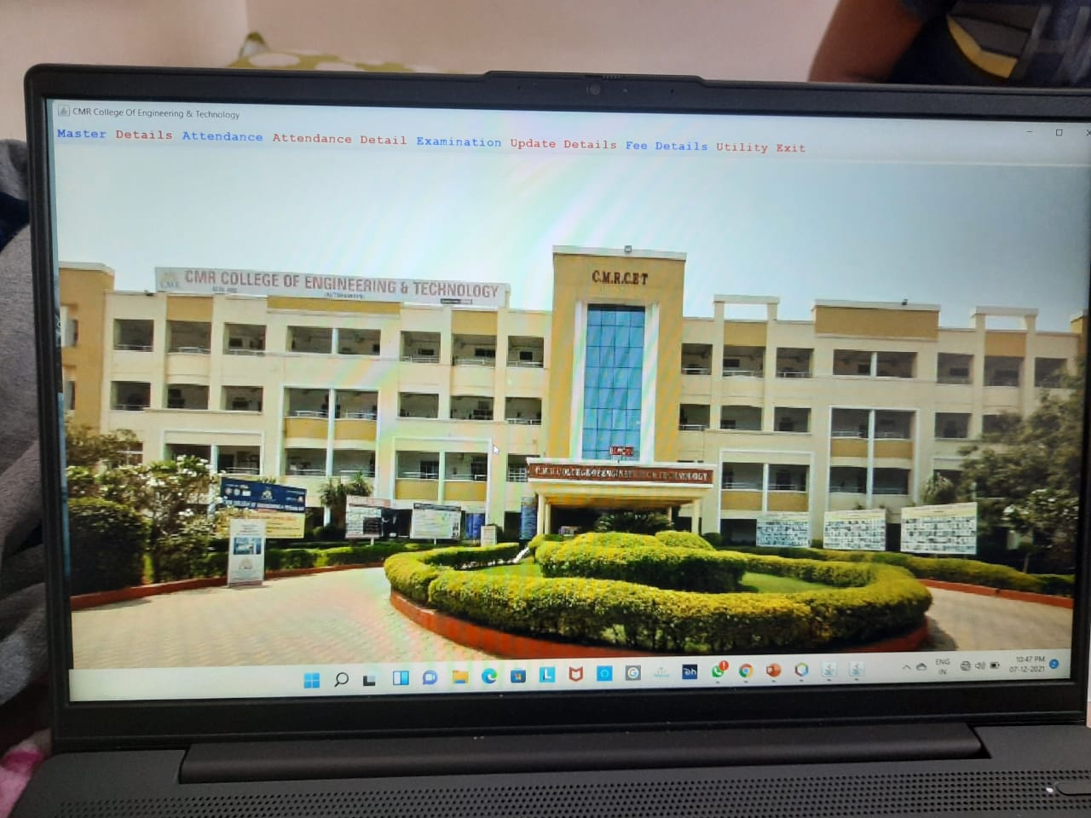

### Figure 5.3: Home page user

**4. Student form :** In this we can add the new student details which will be stored in back end of user.This details further can updated in the update page.

### Figure 5.4: Student form

**5. Teacher form:** In this we can add the new teacher details which will be stored in back end of user. This details further can updated in the update page.

### Figure 5.5: Teacher form

**6. Marks and Subject page :** In this page we can enter the subjects and marks scored in that particular subject along the roll no.

### Figure 5.6: Marks and Subject page

**7. Fee payment page :** In this page we can the pay the fee dues of the particular student which uses rollno,course,branch and sem to pay the fee.

**Figure 5.7: Fee payment page**

# **CONCLUSION**

* + - The project entitled as **University Management System** is the system that deals with the issues related to a particular institution.
    - This project is successfully implemented with all the features mentioned in system requirements specification.
    - The application provides appropriate information to users according to the chosen service.
    - The project is designed keeping in view the day-to-day problems faced by a college.
    - Deployment of our application will certainly help the college to reduce unnecessary wastage of time in personally going to each department for some information.
    - Awareness and right information about any college is essential for both the development of student as well as faculty. So, this serves the right purpose in achieving the desired requirements of both the communities.

**REFERENCES**

* Internet & World Wide Web: How to Program Deitel, PJ Deitel.
* Thinking in Java, Bruce Eckel and Pearson Education.
* Object Oriented Programming through java, P. Radha Krishna, Universities Press.
* Code for Interview YouTube Channel.
* Database System Concepts, by Silberschatz, Sudarshan, and Korth.
* https://github.com/topics/university-management